Task 1: Create a Bash Script to Check Whether a Directory Exists or Not
Outcome - A Bash shell script is successfully created to verify whether a specified directory exists on the Linux system. The script displays an appropriate message depending on the directory's availability.
Objective - Automate checking whether a directory exists in a Linux environment using a Bash script.
Prerequisites
Before performing this task, the following prerequisites are required:
- A Linux system or virtual machine
- Basic knowledge of Linux commands
- User access with permission to create and execute scripts
- A text editor such as vi, vim, or nano
Step-by-Step Implementation
Step 1: Navigate to the Desired Location
First, log in to the Linux server and move to the directory where the script needs to be created.
cd /divya/scripts
This command changes the current working directory to /divya/scripts.
Step 2: Create a Shell Script File
Create a new shell script file using the vi editor. ---- vi checkdir.sh
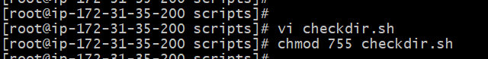
Step 3: Add the Bash Script
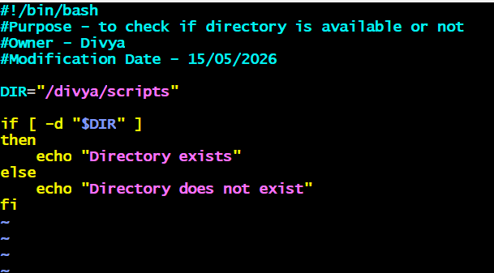
Script Explanation
The script starts with #!/bin/bash, which is called the shebang line. It tells the Linux system to execute the script using the Bash shell.
The echo command displays a message asking the user to enter a directory path. The read command stores the user input into the variable DIR.
The condition if [ -d "$DIR" ] checks whether the specified path is a directory.
- -d is a test operator used to verify directories.
- If the directory exists, the script prints "Directory exists."
- Otherwise, it prints "Directory does not exist."
Step 4: Provide Execute Permission
Before running the script, execute permission must be assigned.

Step 5: Execute the Script
Run the script using the command ./checkdir.sh
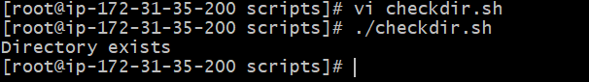
Directory exists.
If the directory is unavailable:
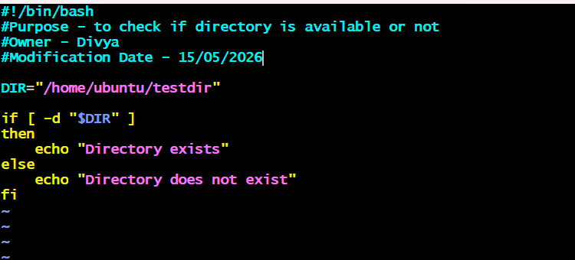
Enter Directory Path:
directory does not exist.

Task 2: Create Multiple Files Using a Bash Script
Outcome: A Bash shell script was successfully created to automate the creation of multiple files in a Linux environment. After executing the script, five files named file1, file2, file3, file4, and file5 were created successfully in the current working directory.
Objective: Automate the creation of multiple files using a Bash shell script.
Step-by-Step Implementation
Step 1: Navigate to the Working Directory
First, log in to the Linux server and navigate to the directory where the script file needs to be created.
cd /divya/scripts
Step 2: Create the Shell Script File
Create a new Bash script file using the vi editor. vi createfiles.sh
Step 3: Add the Bash Script
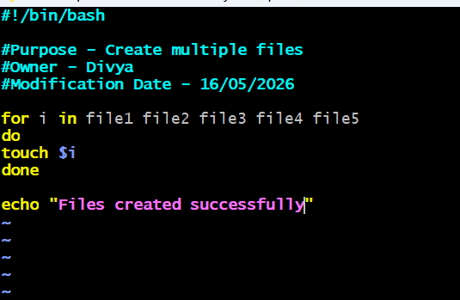
Script Explanation
The script starts with the shebang line: #!/bin/bash
This line tells the Linux operating system to run the script using the Bash shell.
The for loop iterates over the list of filenames.
for i in file1 file2 file3 file4 file5
During each iteration, the variable i stores a single filename.
The touch command is used to create the files.
touch $i
The loop continues until all five files are created successfully.
Finally, the script displays a success message using the echo command.
echo "Files created successfully"
Step 4: Provide Execute Permission
Before running the script, execute permission must be assigned. chmod 755 createfiles.sh
Step 5: Execute the Script
Run the script using the following command:
./createfiles.sh
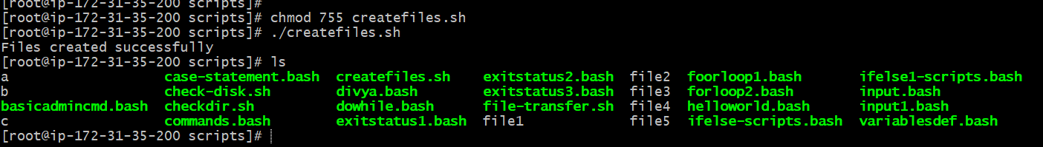
Step 7: Verify the Created Files
Use the ls command to verify whether the files were created successfully.
Example Output:
file1 file2 file3 file4 file5
Validation Steps
The task can be validated by checking the current directory contents using the ls command. If the script executes successfully, the files file1, file2, file3, file4, and file5 should appear in the directory listing.
Task 3: Create a Bash Script to Take a Backup of a Directory
Outcome: A Bash shell script was successfully created to automate the backup process of a directory in a Linux system. After running the script, a backup of the specified directory was created successfully, with the current date and time appended to the backup name.
Objective: Automate directory backups using a Bash script.
Step-by-Step Implementation
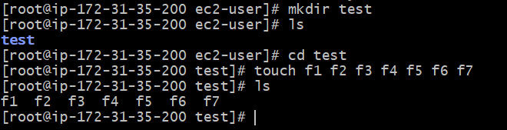
Step 1: Navigate to the Working Directory
First, log in to the Linux server and navigate to the location where the script file needs to be created.
cd /divya/scripts
Step 2: Create the Shell Script File
Create a new Bash script file using the vi editor---vi backup_directory.sh
Step 3: Add the Bash Script
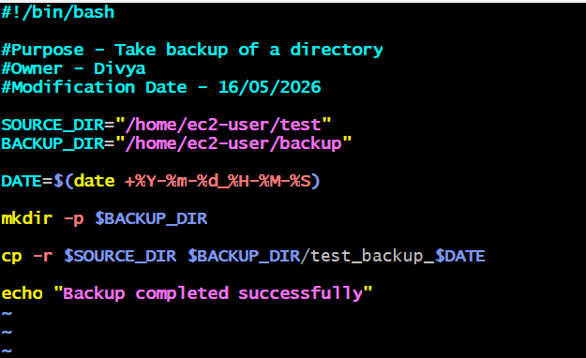
Script Explanation
The script begins with the shebang line:
#!/bin/bash
This line tells the Linux system to run the script using the Bash shell.
The comment section provides script-related information such as purpose, owner name, and modification date. These comments improve readability and help maintain scripts in production environments.
The variable SOURCE_DIR stores the path to the directory to be backed up.
SOURCE_DIR="/home/ec2-user/test"
The variable BACKUP_DIR stores the location where the backup will be saved.
BACKUP_DIR="/home/ec2-user/backup"
The following command stores the current date and time in the variable DATE.
DATE=$(date +%Y-%m-%d_%H-%M-%S)
This helps create unique backup names and prevents overwriting previous backups.
The command below creates the backup directory if it does not already exist.
mkdir -p $BACKUP_DIR
The cp -r command recursively copies the entire source directory to the backup location.
cp -r $SOURCE_DIR $BACKUP_DIR/test_backup_$DATE
Finally, the script displays a success message.
echo "Backup completed successfully."
Step 4: Provide Execute Permission
Before running the script, execute permission must be assigned.
Step 6: Execute the Script
Run the script using the following command: ./backup_directory.sh
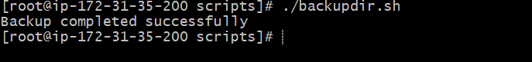
Example Output:
Backup completed successfully
Screenshot Evidence
(Mandatory)

Step 7: Verify the Backup
Navigate to the backup directory and verify whether the backup was created successfully.
cd /home/ec2-user/backup
List the backup contents:
Ls
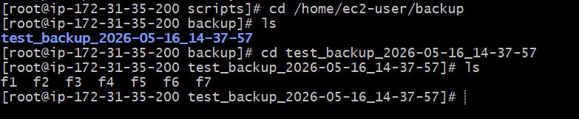
Validation Steps
The task can be validated by checking whether the backup directory contains the copied files and folders from the original source directory.
Task 4: Create a Bash Script to Install Nginx on an Amazon Linux EC2 Server
Outcome: A Bash shell script was successfully created and executed to install the Nginx web server on an Amazon Linux EC2 instance. After execution, the Nginx package was installed, the service was started, and Nginx was enabled to start automatically during system boot.
Objective: The objective of this task is to automate the installation of the Nginx web server on an Amazon Linux EC2 instance using a Bash shell script.
Step-by-Step Implementation
Step 1: Connect to the Amazon Linux EC2 Server
Login to the EC2 server using SSH.
ssh -i mykey.pem ec2-user@3.144.197.132
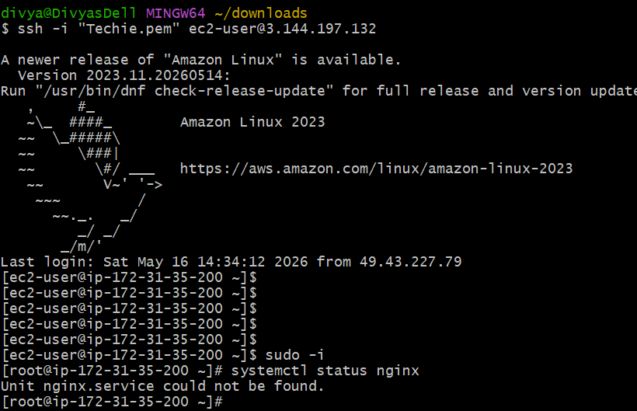
Step 2: Create the Shell Script File
Create a new Bash script file using the vi editor. --- vi nginx_install.sh
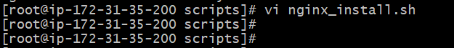
Step 3: Add the Bash Script
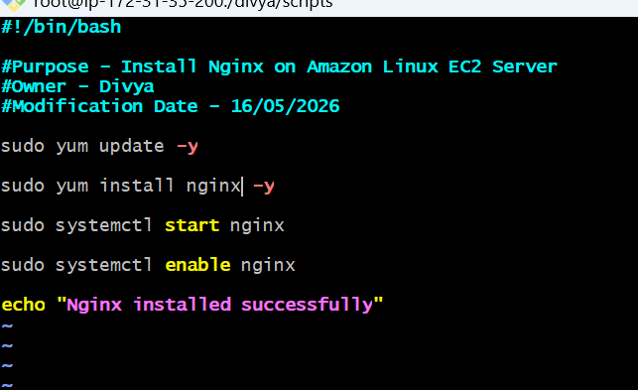
Script Explanation
The script starts with:
#!/bin/bash
This line tells the Linux operating system to execute the script using the Bash shell interpreter.
The following command updates all installed packages in the system.
sudo yum update -y
The yum package manager is used in Amazon Linux distributions for software installation and package management.
The following command installs Nginx using Amazon Linux Extras.
sudo yum install nginx -y
Amazon Linux provides some packages through the amazon-linux-extras repository.
The command below starts the Nginx service.
sudo systemctl start nginx
The following command enables Nginx to start automatically after a server reboot.
sudo systemctl enable nginx
Finally, the script displays a success message.
echo "Nginx installed successfully."
Step 4: Provide Execute Permission
Assign execute permission to the script.
chmod +x nginx_install.sh
Step 5: Execute the Script
Run the script using the following command:
./nginx_install.sh
Example Output:
Nginx installed successfully
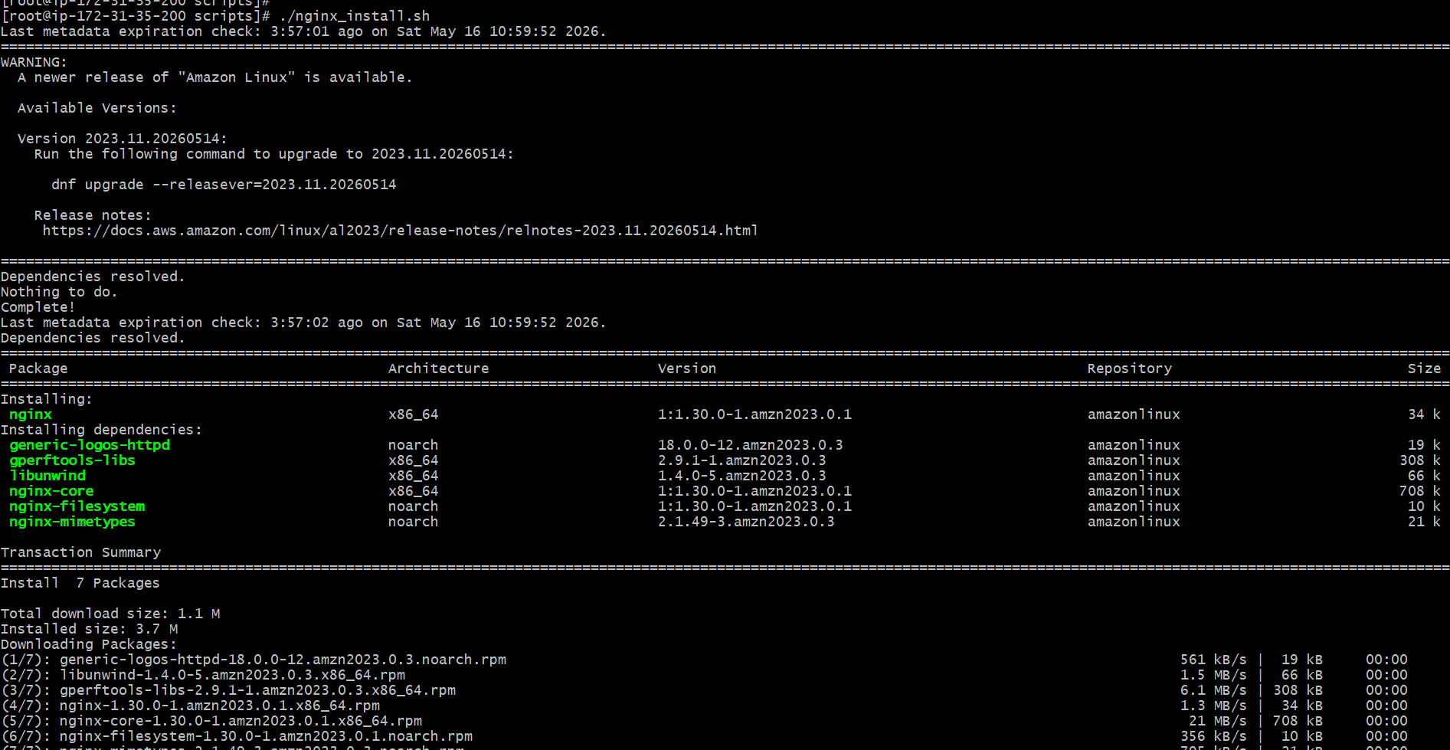
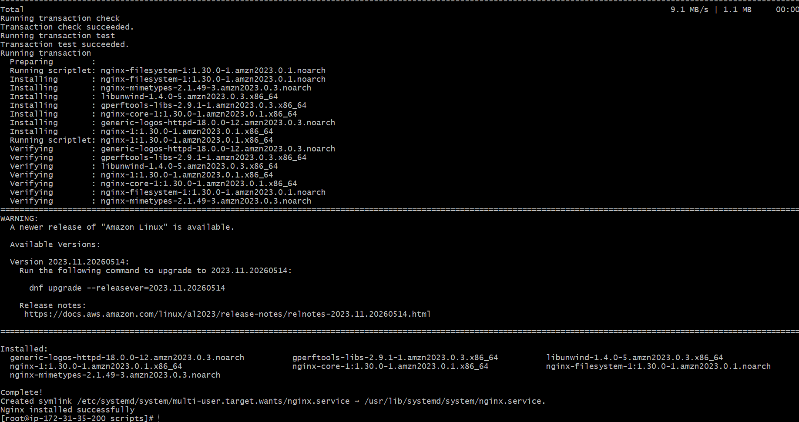Step 6: Verify Nginx Service Status
Check whether the Nginx service is running successfully.
sudo systemctl status nginx
Example Output:
Active: active (running)
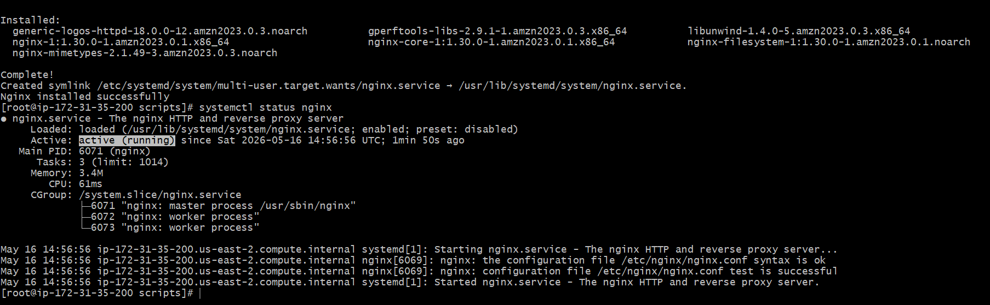Step 8: Access Nginx in Browser
Copy the EC2 Public IP address and open it in a browser.
Example:
http://54.210.10.25
The default Nginx welcome page should appear successfully.
Validation Steps
The installation can be validated by checking:
- Nginx service status
- Browser accessibility through Public IP
- Port 80 accessibility in AWS Security Group
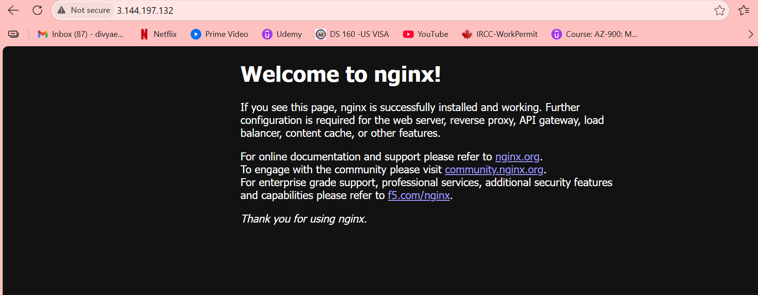
Task 5: Create a Bash Script to Install Apache Tomcat on an Amazon Linux EC2 Server
Outcome: A Bash shell script was successfully created and executed to automate the installation of Apache Tomcat on an Amazon Linux EC2 server. The script installed Java, downloaded Apache Tomcat, extracted the package, configured required permissions, and started the Tomcat service successfully.
After successful execution, the Apache Tomcat application became accessible through port 8080 in the browser.
Objective: Automate the installation and configuration of Apache Tomcat using a Bash script on an Amazon Linux EC2 instance.
Step-by-Step Implementation
Step 1: Connect to the EC2 Server
Log in to the Amazon Linux EC2 server using SSH.
ssh -i mykey.pem ec2-user@54.210.10.25
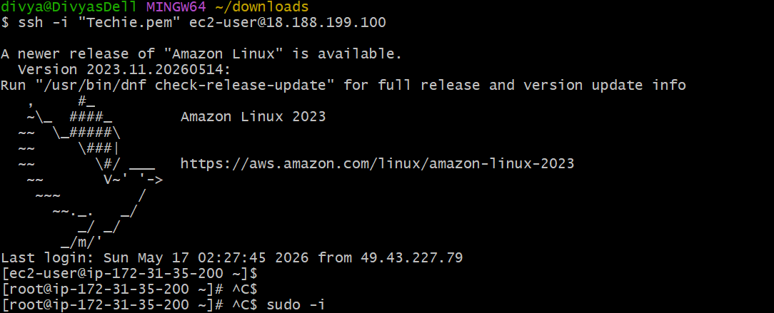
Step 2: Create the Bash Script File
Create a new shell script file using the vi editor. ---- vi tomcat_install.sh
Step 3: Add the Bash Script
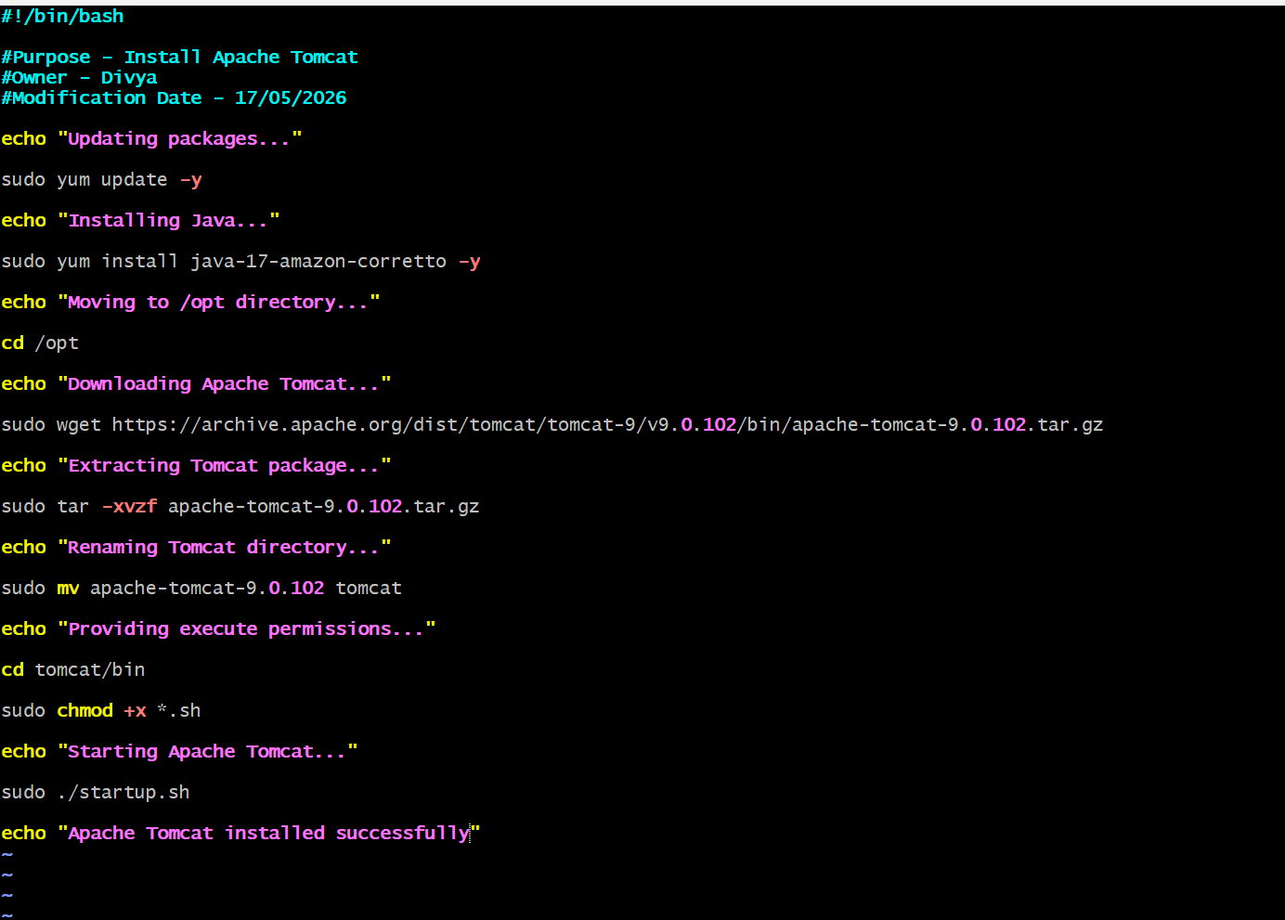
Script Explanation
The script begins with:
#!/bin/bash

#Purpose - Install Apache Tomcat
#Owner - Divya
#Modification Date - 17/05/2026
echo "Updating packages..."
sudo yum update -y
echo "Installing Java..."
sudo yum install java-17-amazon-corretto -y
echo "Moving to /opt directory..."
cd /opt
echo "Downloading Apache Tomcat..."
sudo wget https://archive.apache.org/dist/tomcat/tomcat-9/v9.0.102/bin/apache-tomcat-9.0.102.tar.gz
echo "Extracting Tomcat package..."
sudo tar -xvzf apache-tomcat-9.0.102.tar.gz
echo "Renaming Tomcat directory..."
sudo mv apache-tomcat-9.0.102 tomcat
echo "Providing execute permissions..."
cd tomcat/bin
sudo chmod +x *.sh
echo "Starting Apache Tomcat..."
sudo ./startup.sh
echo "Apache Tomcat installed successfully"

#!/bin/bash
This line tells the Linux operating system to execute the script using the Bash shell interpreter.
The following command updates all installed packages:
sudo yum update -y
Java is required to run Apache Tomcat. The script installs Java using:
sudo yum install java-17-amazon-corretto -y
The script then moves to the /opt directory where Tomcat will be installed.
cd /opt
The Tomcat package is downloaded using the wget command.
sudo wget https://dlcdn.apache.org/tomcat/tomcat-9/v9.0.106/bin/apache-tomcat-9.0.106.tar.gz
The downloaded file is extracted using:
sudo tar -xvzf apache-tomcat-9.0.106.tar.gz
The extracted directory is renamed to tomcat for easier access.
sudo mv apache-tomcat-9.0.106 tomcat
Execute permissions are provided to all shell scripts inside the Tomcat bin directory.
sudo chmod +x *.sh
Finally, Tomcat is started using:
sudo ./startup.sh
The script displays a success message after the installation completes.
Step 4: Provide Execute Permission
Assign execute permission to the script.
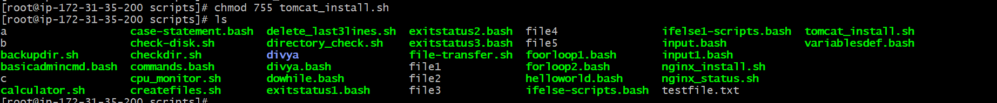
Step 6: Execute the Script
Run the script using: ./tomcat_install.sh
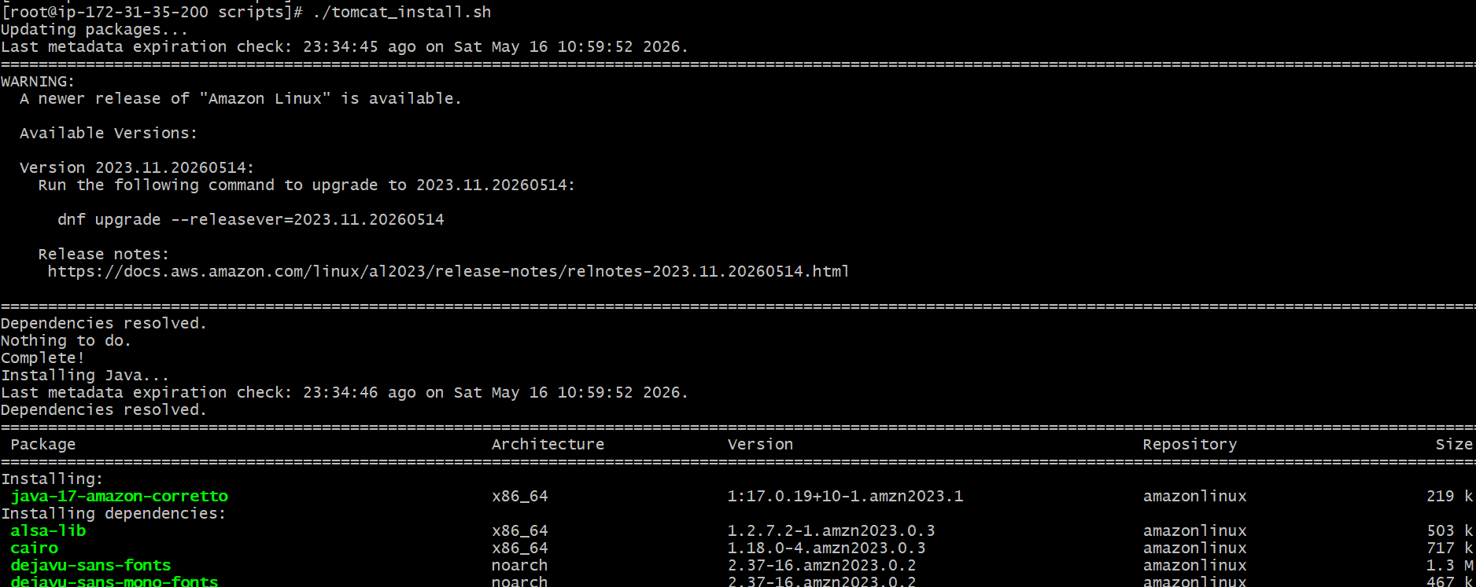
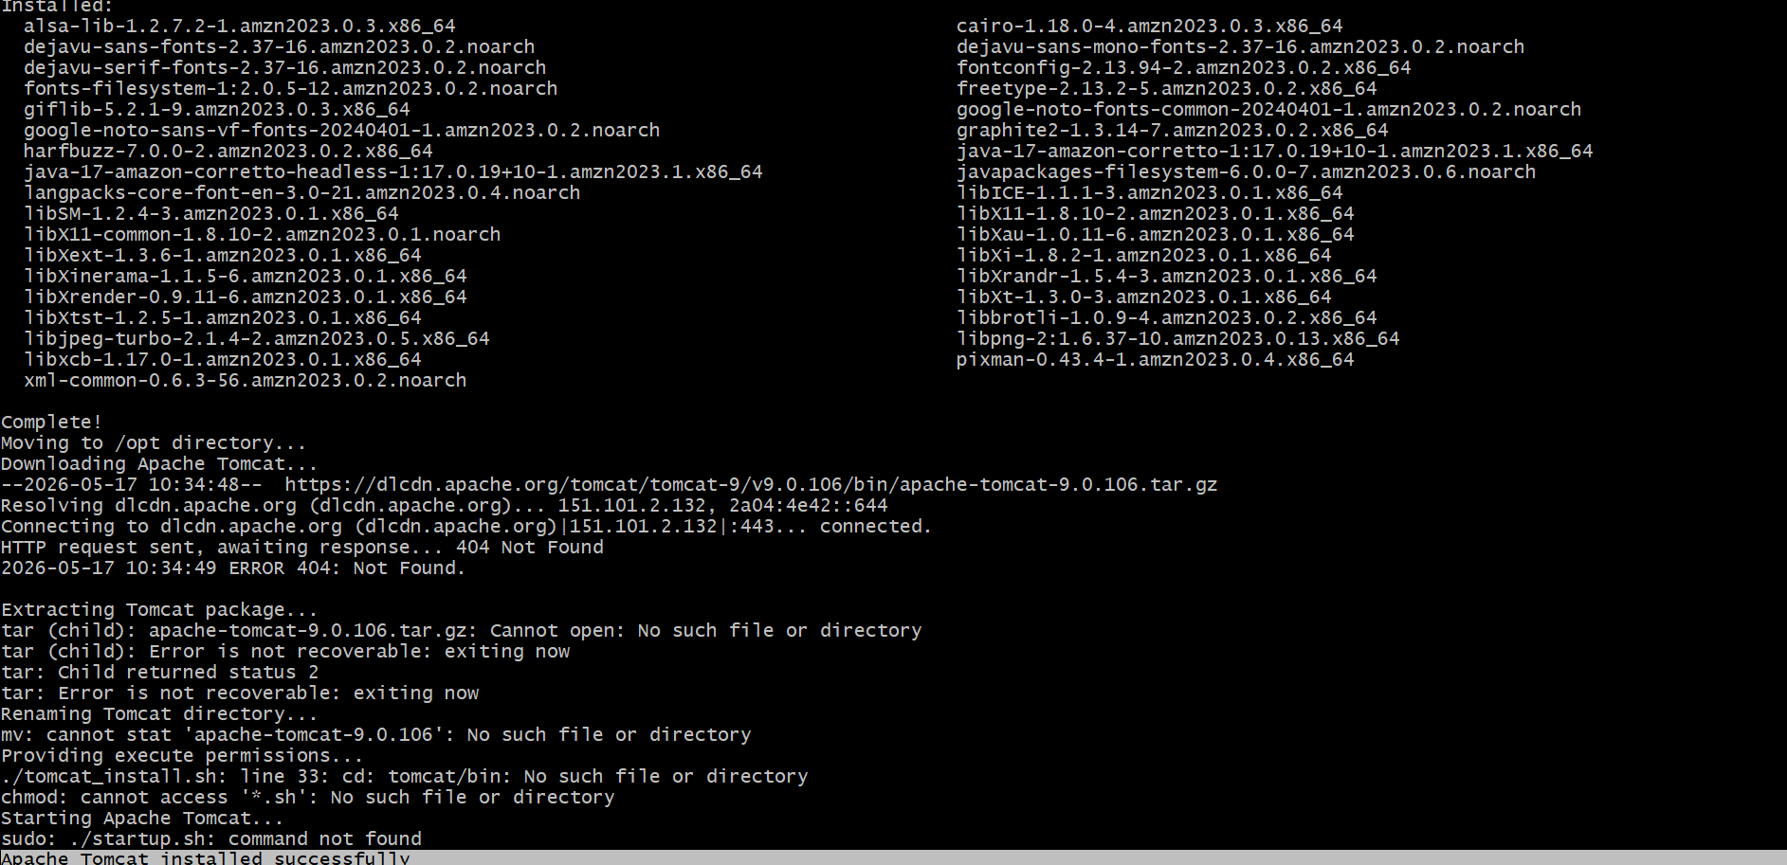Step 7: Verify Tomcat Process
Check whether Tomcat is running successfully.
ps -ef | grep tomcat
Example Output:
tomcat process running
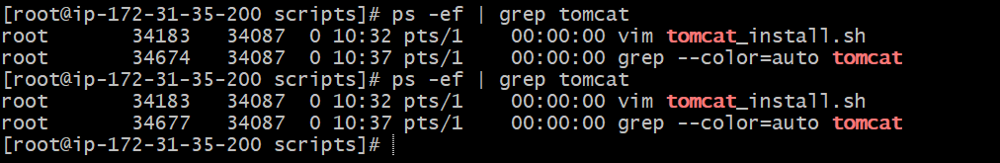
Step 8: Access Tomcat in the Browser
Open the browser and access:
http://<EC2-Public-IP>:8080
Example:
http://54.210.10.25:8080
The Apache Tomcat welcome page should appear successfully.
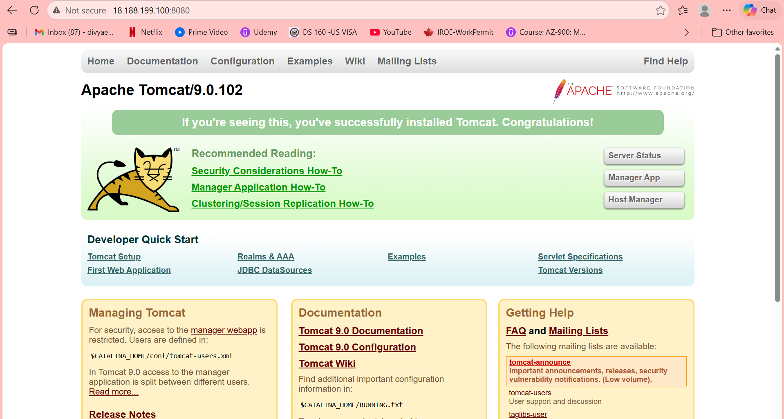
Validation Steps
The installation can be validated by:
- Checking Java installation
- Verifying Tomcat process status
- Accessing the Tomcat application through port 8080
Validation command:
ps -ef | grep tomcat
Tomcat processes should be visible.
Task 6: Create a Bash Script to Check Nginx Service Status and Start the Service if it is Not Running
Outcome: A Bash shell script was successfully created to monitor the Nginx service status on a Linux server. The script checks whether the Nginx service is running; if it is stopped, it automatically starts it.
Objective: Automate Nginx service monitoring and management using a Bash script.
Step-by-Step Implementation
Step 1: Connect to the Server
Login to the Linux or EC2 server using SSH.

Step 2: Create the Script File
Create a new Bash script file using the vi editor ---- vi nginx_status.sh
Step 3: Add the Bash Script
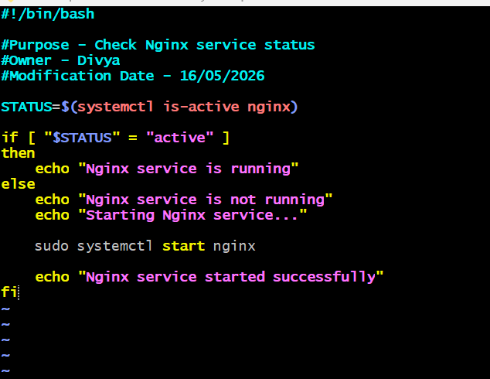
Script Explanation
The script starts with:
#!/bin/bash
This line tells the Linux system to run the script using the Bash shell.
The following command checks the status of the Nginx service.
The command's output is stored in the variable STATUS.
If the service is running, the command returns:
active
The script then uses an if condition to verify the service status.
if [ "$STATUS" = "active" ]
If Nginx is already running, the script displays:
Nginx service is running
If the service is not running, the script automatically starts the Nginx service using:
sudo systemctl start nginx
Finally, the script displays a success message after starting the service.
Step 4: Provide Execute Permission
Assign execute permission to the script.
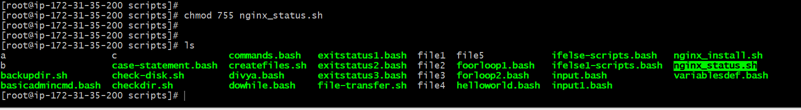
Step 5: Execute the Script
Run the script using the following command: ./nginx_status.sh
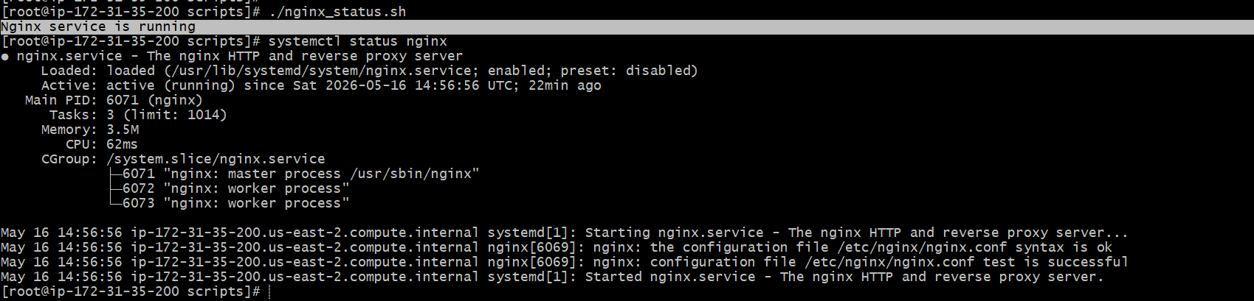
Example Output if Nginx is stopped:
Nginx service is not running
Starting Nginx service...
Nginx service started successfully
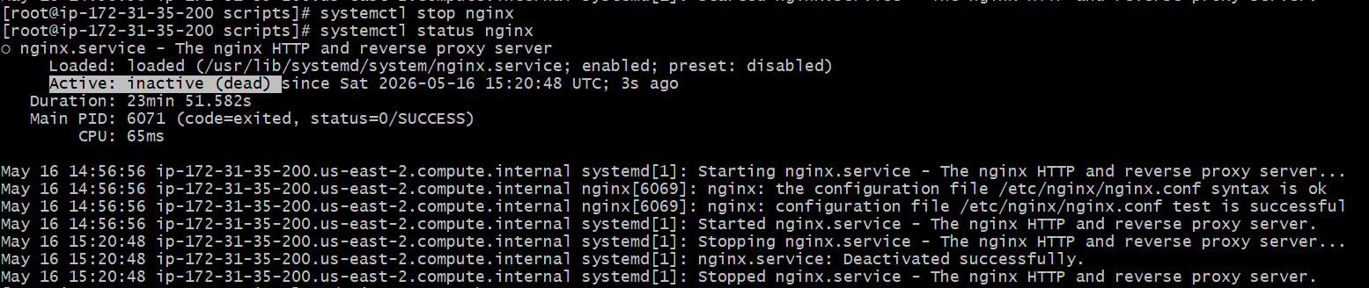
Step 7: Verify Nginx Service Status
Check whether the service is running successfully.
sudo systemctl status nginx
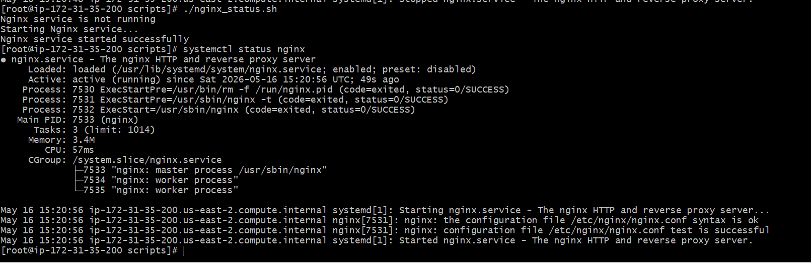
Validation Steps
The task can be validated by:
- Stopping the Nginx service manually
- Running the script
- Verifying whether the script starts the service automatically
Use the following command to stop Nginx for testing: sudo systemctl stop nginx
Then execute the script again.
Validation command: sudo systemctl status nginx
The status should display: active (running)
Task 7: Create a Bash Script for a Calculator
Outcome: A Bash shell script was successfully created to perform basic arithmetic calculations in a Linux system. The script accepts two numbers from the user and performs operations such as addition, subtraction, multiplication, and division.
Objective: The objective of this task is to create a simple calculator using a Bash shell script.
Step-by-Step Implementation
Step 1: Navigate to the Working Directory
Log in to the Linux server and navigate to the location where the script file will be created.
cd /divya/scripts
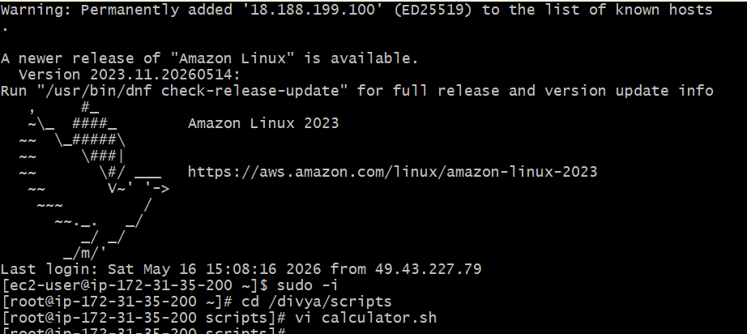
Step 2: Create the Script File
Create a new shell script file using the vi editor.
vi calculator.sh
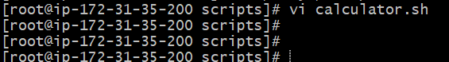
Step 3: Add the Bash Script
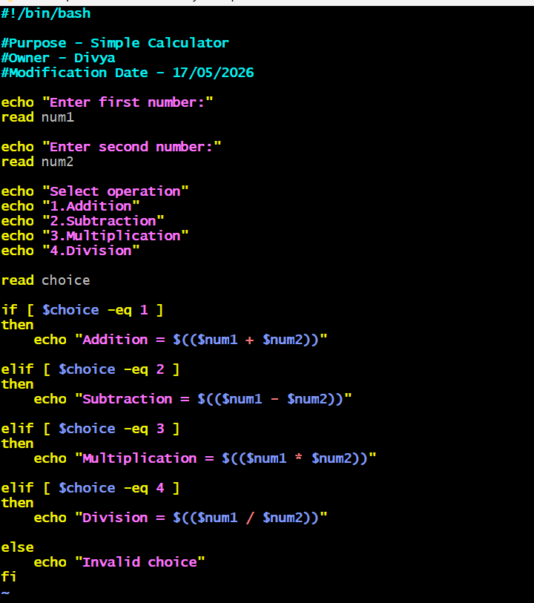
Script Explanation
The script starts with:
#!/bin/bash
This line tells the Linux system to execute the script using the Bash shell interpreter.
The script uses the echo command to display messages and the read command to accept user input.
read num1
read num2
The user enters two numbers for calculation.
The script then displays a list of arithmetic operations and stores the selected option in the variable choice.
read choice
Conditional statements (if, elif, else) are used to perform the selected operation.
For example, addition is performed using:
$(($num1 + $num2))
Similarly, subtraction, multiplication, and division operations are also handled inside the script.
If the user enters an invalid option, the script displays:
Invalid choice
After entering the script using :wq!
Step 4: Provide Execute Permission
Assign execute permission to the script.
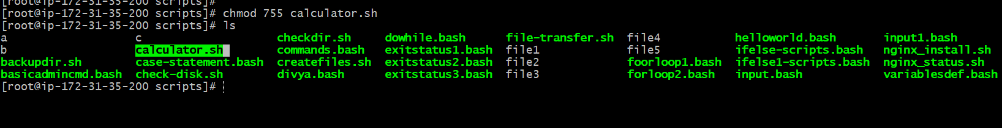
Step 5: Execute the Script
Run the script using the following command:
./calculator.sh
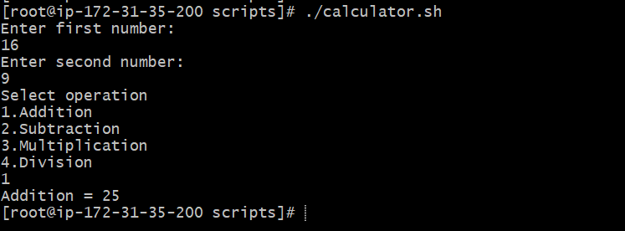
Validation Steps
The task can be validated by:
- Executing the script
- Providing numeric input values
- Selecting arithmetic operations
Verifying whether the displayed result is correct
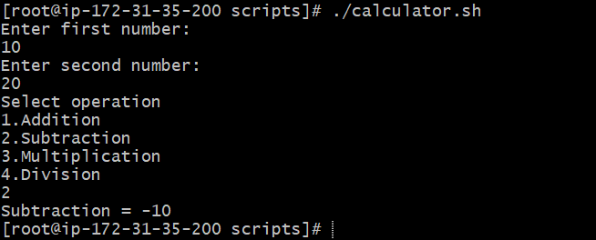
Task 8: Create a Bash Script to Check if a Directory Exists, If Not Then Create the Directory
Outcome: A Bash shell script was successfully created to check whether a directory exists in the Linux system. If the directory already exists, the script displays a message indicating its presence. If the directory is unavailable, the script automatically creates it.
Objective: Automate directory validation and creation using a Bash script.
Step-by-Step Implementation
Step 1: Navigate to the Working Directory
Login to the Linux server and move to the location where the script file needs to be created.
cd /divya/scripts
Step 2: Create the Script File
Create a new shell script file using the vi editor. vi directory_check.sh
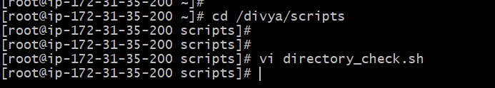
Step 3: Add the Bash Script
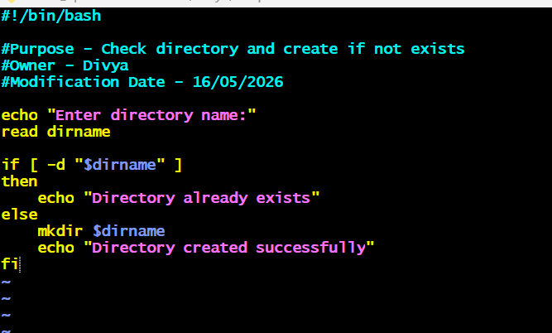
Script Explanation
The script begins with:
#!/bin/bash
This line tells the Linux operating system to execute the script using the Bash shell interpreter.
The echo command displays a message asking the user to enter the directory name.
echo "Enter directory name:"
The read command stores the entered value in the variable dirname.
read dirname
The following condition checks whether the directory already exists.
if [ -d "$dirname" ]
Here:
- -d is used to verify whether the specified path is a directory.
If the directory exists, the script displays:
Directory already exists
If the directory does not exist, the script creates the directory using: mkdir $dirname
Finally, the script displays a success message after creating the directory.
Directory created successfully
Step 4: Provide Execute Permission
Assign execute permission to the script.
Step 5: Execute the Script
Run the script using the following command: ./directory_check.sh
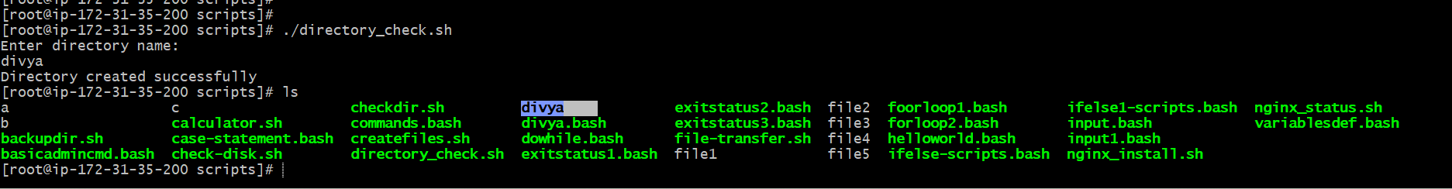
Step 6: Verify the Directory
Use the ls command to verify the directory creation. --- ls
Validation Steps
The task can be validated by:
- Running the script with an existing directory name
- Running the script with a new directory name
Verifying whether the directory is created successfully
Task 9: Create a Bash Script to Delete the Last 3 Lines of a File
Outcome: A Bash shell script was successfully created to remove the last three lines from a file in a Linux system. After running the script, the file contents were successfully updated by deleting the final three lines.
Objective: Automate file modification using a Bash script.
Step-by-Step Implementation
Step 1: Navigate to the Working Directory
Login to the Linux server and move to the location where the script file will be created.
cd /divya/scripts
Step 2: Create a Sample File
Create a sample file for testing.
vi testfile.txt
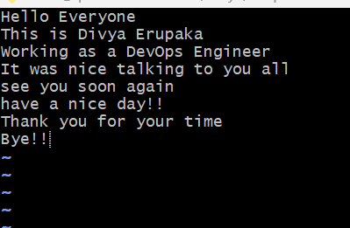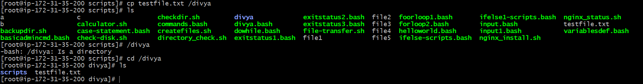
Step 3: Create the Script File
Create a new Bash script file using the vi editor.
vi delete_last3lines.sh
Step 4: Add the Bash Script
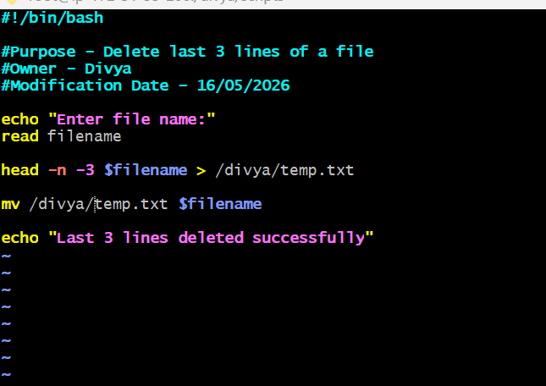
Script Explanation
The script starts with:
#!/bin/bash
This line tells the Linux operating system to execute the script using the Bash shell interpreter.
The script asks the user to enter the file name.
echo "Enter file name:"
read filename
The following command removes the last three lines from the file.
head -n -3 $filename > temp.txt
Explanation:
head displays file contents
-n -3 means display all lines except the last 3 lines
Output is redirected into a temporary file named temp.txt
The following command replaces the original file with the updated file.
mv temp.txt $filename
Finally, the script displays a success message.
echo "Last 3 lines deleted successfully"
Step 5: Provide Execute Permission
Assign execute permission to the script.
Step 7: Execute the Script
Run the script using the following command:
./delete_last3lines.sh
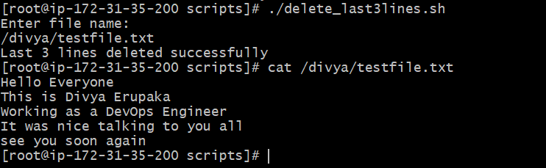
Example Output:
Enter file name:
testfile.txt
Last 3 lines deleted successfully
Step 8: Verify the File Content
Check the updated file contents.
cat testfile.txt
The last three lines were removed successfully.
Task 10: Create a Bash Script to Monitor CPU Usage and Send Email Notification if CPU Usage Exceeds 80%
Outcome: A Bash shell script was successfully created to monitor CPU utilization on a Linux server. The script checks CPU utilization and, if it exceeds 80%, automatically sends an email notification to the administrator.
Objective: Automate CPU monitoring and alert notifications using a Bash script.
Step-by-Step Implementation
Step 1: Install Mail Utility
Install the mail package required for sending email notifications.
For Amazon Linux:
sudo yum install mailx -y
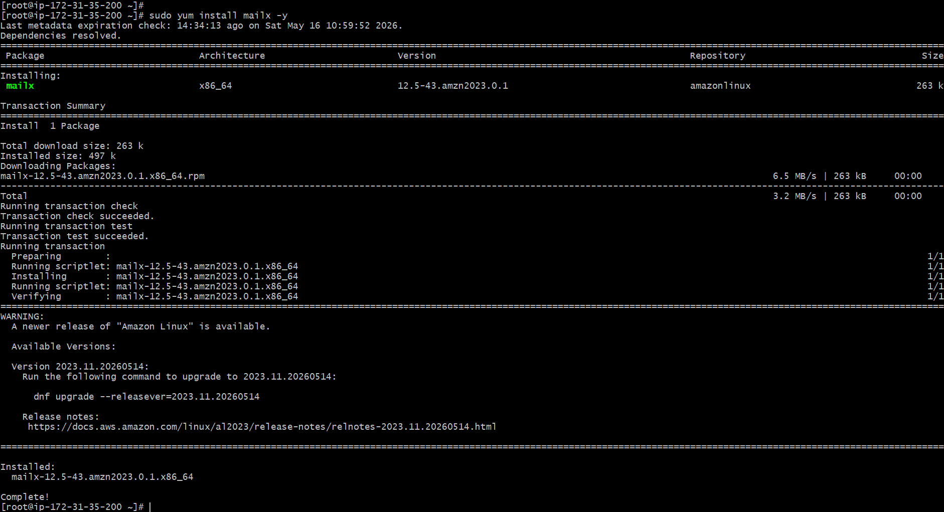
Step 2: Create the Script File
Create a new Bash script file using the vi editor.
vi cpu_monitor.sh
Step 3: Add the Bash Script
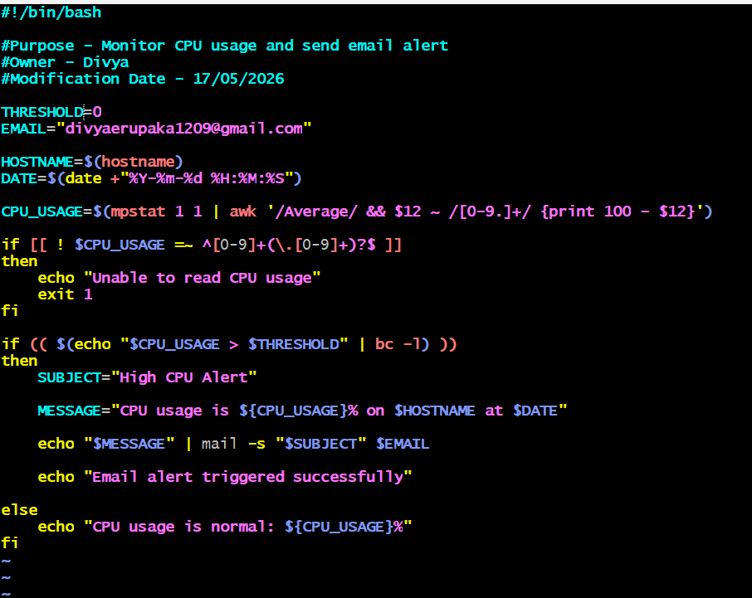
Script Explanation
The script begins with:
#!/bin/bash
This line tells the Linux operating system to execute the script using the Bash shell interpreter.
The following command checks the current CPU utilization.
CPU_USAGE=$(top -bn1 | grep "Cpu(s)" | awk '{print $2}' | cut -d. -f1)
Explanation:
- top -bn1 → Displays CPU usage information
- grep "Cpu(s)" → Filters CPU details
- awk '{print $2}' → Extracts CPU utilization value
- cut -d. -f1 → Removes decimal values
The threshold value is set to 80%.
THRESHOLD=80
The email recipient address is stored in the variable TO.
TO="admin@example.com"
The script checks whether CPU usage exceeds the threshold.
if [ $CPU_USAGE -gt $THRESHOLD ]
If CPU usage is greater than 80%, the script sends an email notification using:
mail -s "High CPU Alert" $TO
If CPU usage is normal, the script displays the current usage percentage.
Step 4: Provide Execute Permission
Assign execute permission to the script.
Step 5: Execute the Script
Run the script using the following command:
./cpu_monitor.sh
Step 7: Verify Email Notification
Check the configured email inbox to verify whether the CPU alert email was received successfully.
Example Email Subject:
High CPU Alert
Validation Steps
The task can be validated by:
- Running the script manually
- Simulating high CPU utilization
- Verifying whether email alerts are generated successfully
Validation command: top
Task 11: Bash Script to Monitor Disk Space and Send Email Notification if Usage is More Than 80%
Outcome: A Bash shell script was successfully created to monitor disk space utilization on a Linux server. The script checks the current disk usage percentage and sends an email notification if the disk usage exceeds 80%.
Objective: Automate disk space monitoring using a Bash script and trigger an email alert when disk utilization exceeds a defined threshold.
Prerequisites
Before performing this task, the following prerequisites are required:
- Linux server or Amazon Linux EC2 instance
- User with sudo privileges
- Basic Linux command knowledge
- mailx package installed
- postfix configured for email alerts
- Internet connectivity
Install required packages:
sudo yum install mailx -y
sudo yum install postfix -y
Start postfix service:
sudo systemctl start postfix
Enable postfix service:
sudo systemctl enable postfix
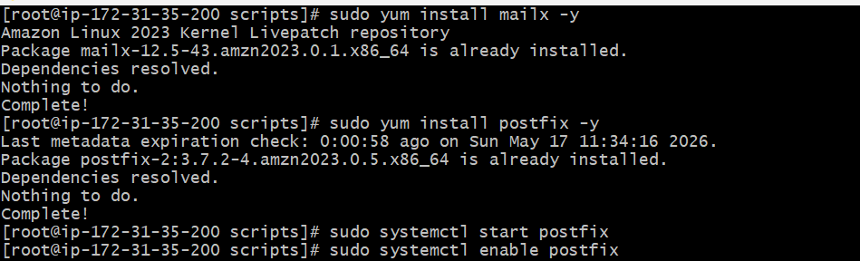

Step-by-Step Implementation
Step 1: Create the Bash Script File
Create a new shell script file.
vi disk_monitor.sh
Step 2: Add the Bash Script
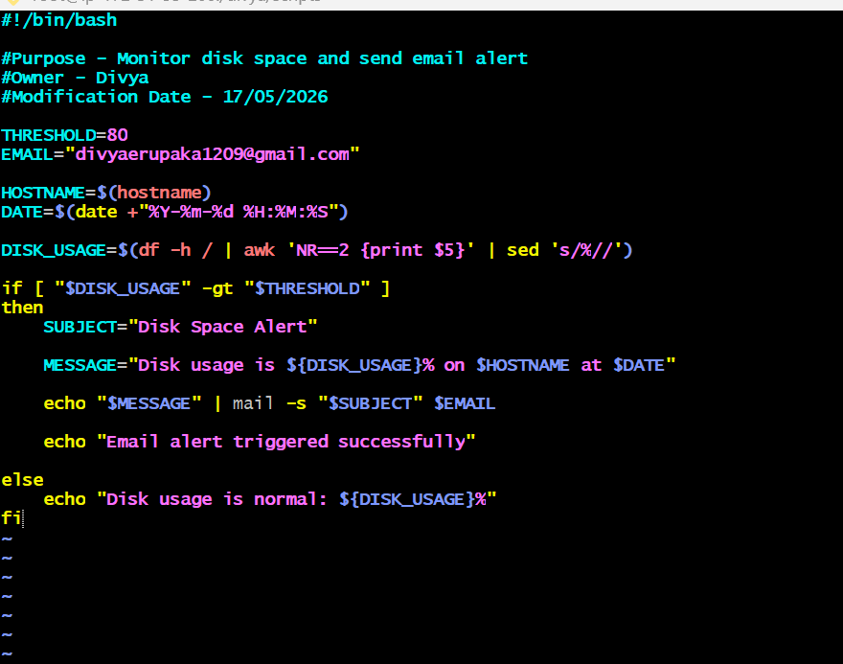
Script Explanation
The script begins with:
#!/bin/bash
This line tells Linux to execute the script using the Bash shell interpreter.
The threshold value is defined as:
THRESHOLD=80
This means an alert will be triggered if disk usage exceeds 80%.
The email address for notifications is stored in:
EMAIL="divyaerupaka1209@gmail.com"
The script collects the server hostname and current date using:
HOSTNAME=$(hostname)
DATE=$(date +"%Y-%m-%d %H:%M:%S")
Disk usage is calculated using the df command:
DISK_USAGE=$(df -h / | awk 'NR==2 {print $5}' | sed 's/%//')
Explanation:
- df -h / displays disk usage of the root partition
- awk extracts the usage percentage
- sed removes the % symbol
The script compares disk usage against the threshold value using:
if [ "$DISK_USAGE" -gt "$THRESHOLD" ]
If usage exceeds 80%, the script sends an email notification using:
echo "$MESSAGE" | mail -s "$SUBJECT" $EMAIL
Otherwise, it displays that disk usage is normal.
Step 4: Provide Execute Permission
Assign execute permission to the script.
chmod 755 disk_monitor.sh
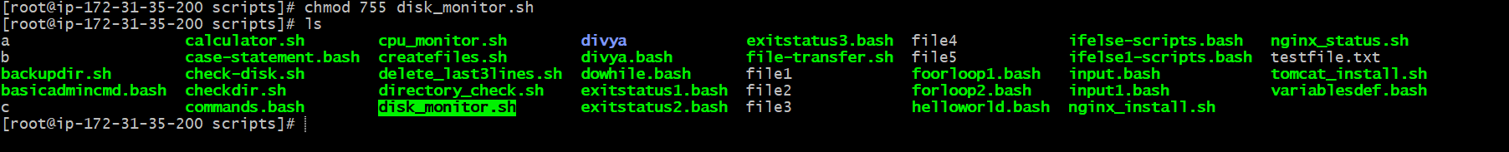
Step 5: Execute the Script
Run the script using: ./disk_monitor.sh
Example Output:
Disk usage is normal: 27%
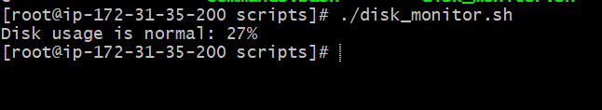
Email alert triggered successfully

Validation Steps
The task can be validated by:
- Executing the script successfully
- Checking current disk utilization
- Verifying alert messages
- Checking mail queue using:
mailq
For testing purposes, temporarily change:
THRESHOLD=0
This forces the alert condition and helps verify email notification functionality.
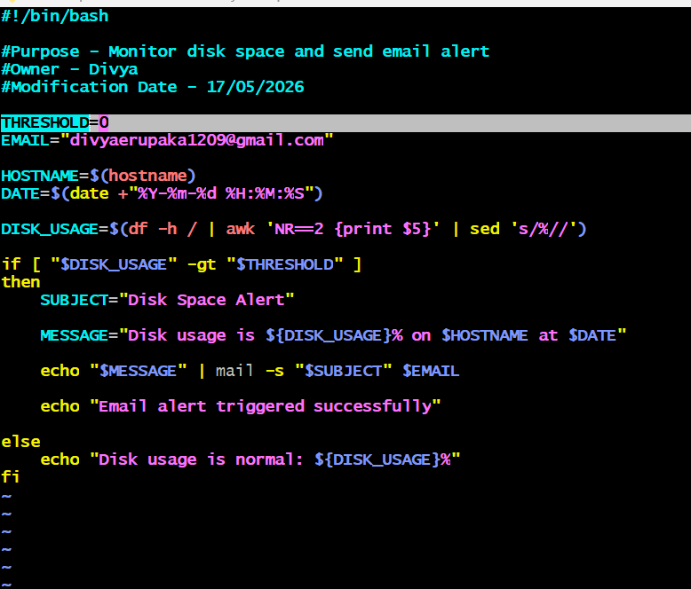
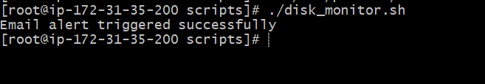
Task 12: Bash Script to Monitor Memory and Send Email Notification if Usage is More Than 80%
Outcome: A Bash shell script was successfully created to monitor memory utilization on a Linux server. The script checks current memory usage percentage and sends an email notification if memory usage exceeds 80%.
The script helps administrators proactively monitor server memory usage and identify potential performance issues before applications or services are impacted.
Objective: The objective of this task is to automate memory monitoring using a Bash shell script and generate an email alert when memory utilization crosses a defined threshold value.
Prerequisites
Before performing this task, the following prerequisites are required:
- Linux server or Amazon Linux EC2 instance
- User with sudo privileges
- Basic Linux command knowledge
- mailx package installed
- postfix mail service configured
- Internet connectivity
Install required packages:

Step-by-Step Implementation
Step 1: Create the Bash Script File
Create a new shell script file.
vi memory_monitor.sh
Step 2: Add the Bash Script
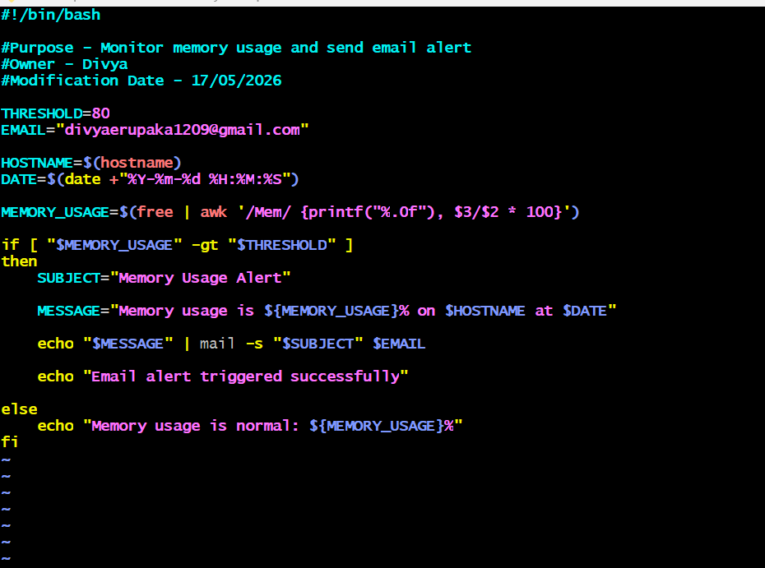
Script Explanation
The script begins with:
#!/bin/bash
This line tells Linux to execute the script using the Bash shell interpreter.
The threshold value is defined using:
THRESHOLD=80
This means the alert will trigger if memory usage exceeds 80%.
The email recipient is stored in:
EMAIL="divyaerupaka1209@gmail.com"
The script collects the hostname and current date using:
HOSTNAME=$(hostname)
DATE=$(date +"%Y-%m-%d %H:%M:%S")
Memory usage is calculated using the free command:
MEMORY_USAGE=$(free | awk '/Mem/ {printf("%.0f"), $3/$2 * 100}')
Explanation:
- free displays memory statistics
- awk calculates memory usage percentage
- printf("%.0f") rounds the value
The script compares memory usage against the threshold:
if [ "$MEMORY_USAGE" -gt "$THRESHOLD" ]
If memory usage exceeds 80%, an email alert is sent using:
echo "$MESSAGE" | mail -s "$SUBJECT" $EMAIL
Otherwise, the script displays normal memory usage status.
Step 4: Provide Execute Permission
Assign execute permission to the script.
chmod 755 memory_monitor.sh
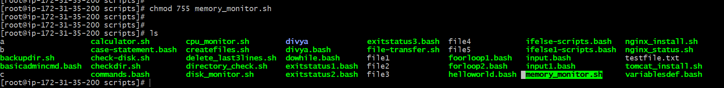
Step 5: Execute the Script
Run the script using:
./memory_monitor.sh
Example Output:
Memory usage is normal: 30%
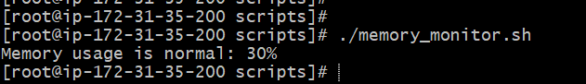
Email alert triggered successfully
Validation Steps
The task can be validated by:
- Executing the script successfully
- Checking current memory utilization
- Verifying alert trigger logic
- Checking mail queue using:
mailq
For testing purposes, temporarily change:
THRESHOLD=0
This forces the alert condition and helps validate email notification functionality.
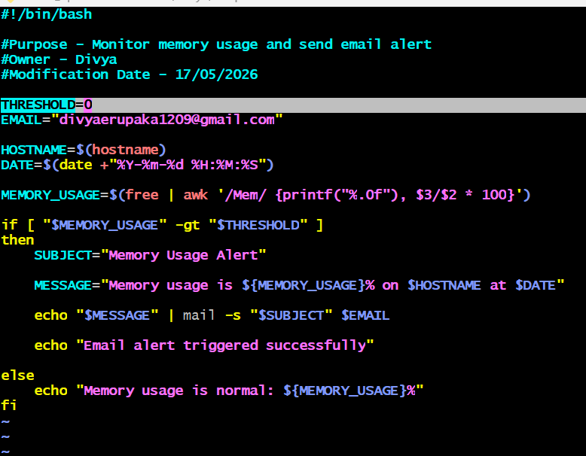
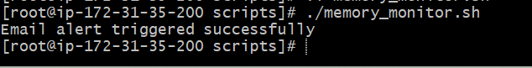

Task 15: Crontab Scheduling Exercises with Example Commands
Outcome: Different cron scheduling expressions were successfully created along with practical command examples. These cron jobs help automate Linux administrative activities such as backups, monitoring, logging, service checks, and cleanup tasks.
Objective: Understand how to create cron schedules and automate real-time Linux tasks using crontab.
Prerequisites
Before performing this task, the following prerequisites are required:
- Linux server or EC2 instance
- User with crontab access
- Basic Linux command knowledge
Open crontab editor:
crontab -e
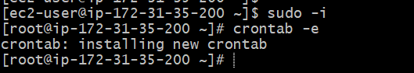
Crontab Format
* * * * * command
- - - - -
| | | | |
| | | | +---- Day of Week
| | | +------ Month
| | +-------- Date
| +---------- Hour
+------------ Minute
Step-by-Step Cron Entries with Commands
1. April 5th Midnight
This cron job runs at 12:00 AM on April 5th every year.
0 0 5 4 * echo "April 5 Midnight Job" >> /tmp/april5.log
Example Use Case
Used for yearly maintenance tasks or annual report generation.
Explanation
- 0 → minute
- 0 → hour
- 5 → date
- 4 → April
2. 5th of Every November, January, June if it is a Thursday
0 0 5 1,6,11 4 echo "Special Thursday Job" >> /tmp/thursday.log
Example Use Case
Used for scheduled audits or quarterly maintenance activities.
Explanation
- 5 → 5th date
- 1,6,11 → Jan, June, Nov
- 4 → Thursday
3. At 05 and 27 Minutes of 9, 10, 11 Hours Every Day
5,27 9-11 * * * df -h >> /tmp/diskusage.log
Example Use Case
Used for periodic disk monitoring during business hours.
Explanation
- 5,27 → minutes
- 9-11 → hours
This executes at:
- 9:05
- 9:27
- 10:05
- 10:27
- 11:05
- 11:27
4. 34 Minutes of 9th Hour on 15th August
34 9 15 8 * echo "Independence Day Task" >> /tmp/aug15.log
Example Use Case
Used for scheduled event-based jobs or notifications.
Explanation
- 34 → minute
- 9 → hour
- 15 → date
- 8 → August
5. Every Midnight
0 0 * * * tar -cvf /backup/home_backup.tar /home
Example Use Case
Used for daily backups.
Explanation
Runs every day at 12:00 AM.
6. Every Weekend (Saturday Night 11:59 PM)
59 23 * * 6 find /tmp -type f -delete
Example Use Case
Used for weekly cleanup of temporary files.
Explanation
- 59 → minute
- 23 → hour
- 6 → Saturday
7. After Every Reboot
@reboot systemctl start nginx
Example Use Case
Used to automatically start services after server reboot.
Explanation
@reboot executes automatically whenever the server starts.
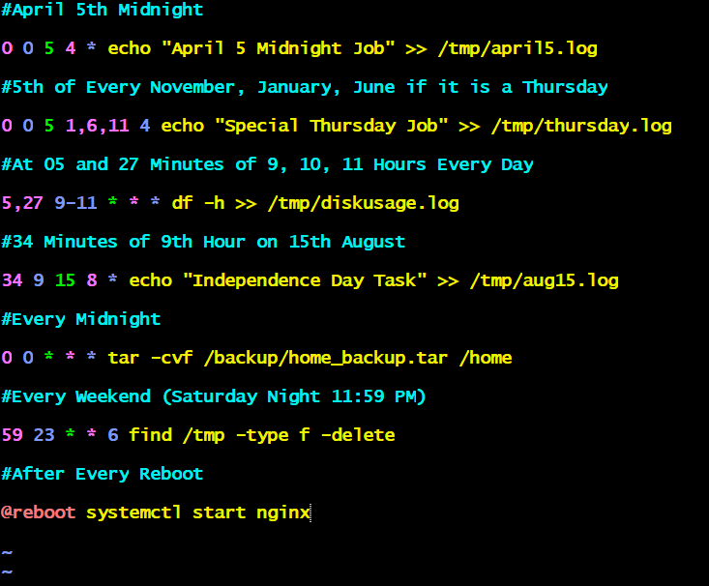
Additional Real-Time Cron Examples
Run Backup Every Day at 2 AM
0 2 * * * tar -cvf /backup/etc_backup.tar /etc

Monitor CPU Every 5 Minutes
*/5 * * * * /root/scripts/cpu_monitor.sh

Check Disk Space Every Hour
0 * * * * /root/scripts/disk_monitor.sh

Restart Apache Every Sunday
0 1 * * 0 systemctl restart httpd

Delete Old Logs Every Month
0 0 1 * * find /var/log -type f -name "*.log" -mtime +30 -delete

Validation Steps
Validation can be performed by:
Check configured cron jobs:
crontab -l
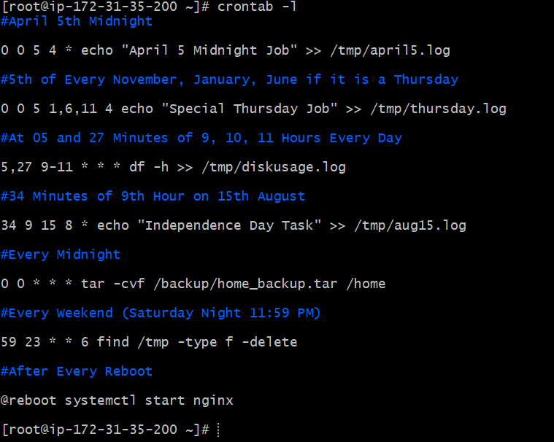
Check cron service status:
systemctl status crond
Start cron service if stopped:
sudo systemctl start crond
Enable cron service:
sudo systemctl enable crond
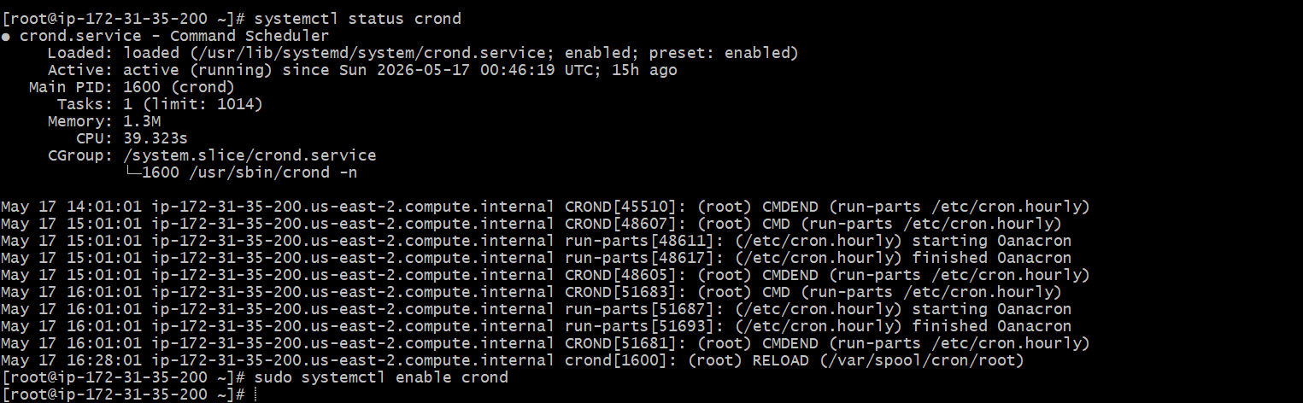
Explanation
In this task, multiple cron scheduling expressions were created with real Linux commands. These schedules automate important administrative operations based on specific dates, times, weekdays, and reboot events.
Cron jobs are an essential part of Linux administration because they reduce manual effort and ensure repetitive operational tasks are executed automatically and consistently.
The exercise demonstrates practical usage of:
- Time-based scheduling
- Backup automation
- Monitoring automation
- Cleanup tasks
- Service management
- Logging operations
To Validate CronJobs Sample test
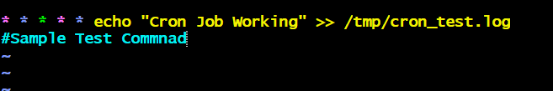
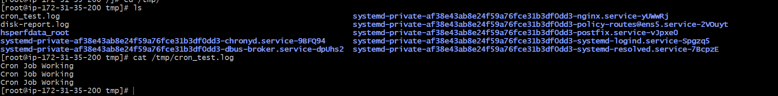
Working on Git Repo:
Step-by-Step Implementation
Step 1: Install Git
Since Git was not installed initially, install Git on Amazon Linux server.
sudo yum install git -y
Step 2: Verify Git Installation
git --version
Expected Output:
git version 2.x.x
Step 3: Navigate to Scripts Directory
cd /divya/scripts
Check files:
ls
Step 4: Initialize Git Repository
git init
Expected Output:
Initialized empty Git repository
Step 5: Configure Git Username
git config --global user.name "DivyaErupaka"
Step 6: Configure Git Email
git config --global user.email "your-email@gmail.com"
Step 7: Connect GitHub Repository
git remote add origin https://github.com/DivyaErupaka/bash-scripting-tasks.git
If remote already exists:
git remote remove origin
Then re-add remote.
Step 8: Add Required Bash Script Files
The following task files were added:
Task | Script File
Directory check | checkdir.sh
Create multiple files | createfiles.sh
Backup directory | backupdir.sh
Install Nginx | nginx_install.sh
Install Tomcat | tomcat_install.sh
Nginx status check | nginx_status.sh
Calculator | calculator.sh
Directory create/check | directory_check.sh
Delete last 3 lines | delete_last3lines.sh
CPU monitoring | cpu_monitor.sh
Disk monitoring | disk_monitor.sh
Memory monitoring | memory_monitor.sh
Command used:
git add checkdir.sh createfiles.sh backupdir.sh nginx_install.sh tomcat_install.sh nginx_status.sh calculator.sh directory_check.sh delete_last3lines.sh cpu_monitor.sh disk_monitor.sh memory_monitor.sh

Step 9: Add Crontab Task File
Create crontab task file:
vi crontab_tasks.txt
Add all cron entries and save file.
Add file to Git:
git add crontab_tasks.txt
Step 10: Create README File
vi README.md
Example content:
# Bash Scripting Tasks
This repository contains Linux Bash scripting tasks including:
- Monitoring scripts
- Backup scripts
- Installation scripts
- Cron scheduling tasks
- Service management scripts
Save file.
Add README:
git add README.md

Step 11: Commit All Files
git commit -m "Added Bash scripting assignment tasks"
Expected Output:
13 files changed
Step 12: Rename Branch to Main
git branch -M main
Step 13: Push Repository to GitHub
git push -u origin main
